**EXPERIMENT 3.1**

**Student Name: Gaurav Kumar UID: 22MCC20177**

**Branch: MCA CC&DEVOPS Section/Group: MCD-1 A**

**Semester: 2ND Date of Performance: 11/05/2023**

**Subject Name: Software Testing Subject Code: 22CAH685**

**The task to be done:**

**How to create a team and add team members in Jira.**

# Steps for experiment/practical: copy and paste your code here/screenshots.

To create a team and add team members in Jira, you need to follow these steps:

1. Log in to your Jira account with appropriate permissions.
2. Navigate to the Jira dashboard or the project where you want to create the team.
3. Click on the "Jira settings" (cogwheel icon) on the top-right corner of the page.
4. In the dropdown menu, select "System" or "Project Settings," depending on your access level.
5. Under the "User Management" or "People" section, find the option for "Groups" or "Teams" and click on it.

1. On the Groups/Teams page, click on the "Create" or "Add Team" button.

1. Provide a name for your team and optionally add a description to provide more context.
2. Save the team by clicking on the "Create" or "Save" button.
3. Once the team is created, you can add members to it by clicking on the team's name or selecting the team from the list.
4. On the team page, there should be an option to "Manage Members" or "Add Members." Click on it.
5. In the member management interface, you can search for users by name, username, or email address.
6. As you type, Jira will suggest matching users. Select the desired user(s) from the suggestions.
7. Repeat the process for adding more members to the team.
8. Once you have added all the team members, save the changes.

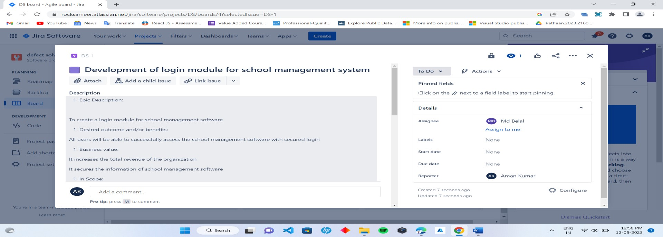

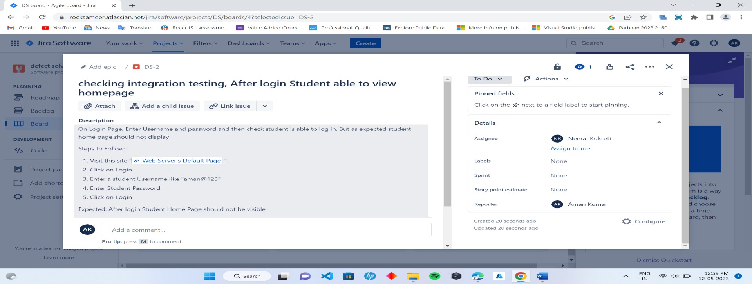

# Learning outcomes (What I have learned):

1. How to create Team.
2. Assignee bugs to team members.

**Evaluation Grid:**

|  |  |  |  |
| --- | --- | --- | --- |
| Sr. No. | Parameters | Marks Obtained | Maximum Marks |
| 1. | Demonstration and Performance (Quiz) |  | 22 |
| 2. | Worksheet |  | 8 |